ASSIGNMENT 2
Apply, Compare and Justify Image Enhancement and Segmentation Techniques
Smart Document Scanner for the College Library
Evidence-based classical image-processing experiments and design decisions
Name | Archana V | Course Code | ITA0516
Reg. No. | 192521420 | Academic Year | 2026-27
Course | Computer Vision | Faculty Name | Dr.Bindu
Course Outcome | 2 | Total marks | 50

Contents
1. Dataset, assumptions and reproducibility
2. Task 1 — Grey-level transformations
3. Task 2 — Histogram processing
4. Task 3 — Smoothing filters
5. Task 4 — Sharpening filters
6. Task 5 — Frequency-domain low-pass filters
7. Task 6 — Frequency-domain high-pass filters
8. Task 7 — Point, line and edge detection
9. Task 8 — Thresholding and binarization
10. Task 9 — Region segmentation and integrated pipeline
11. Task 10 — Adaptation to phone photographs
12. Final design decisions
Appendix A — Reproduction and measured limitations
References

1. Dataset, assumptions and reproducibility
The classical experiments use all 10 paired images in the official DIBCO 2019 Track A test set, with its corresponding pixel-level binary ground truth [1]. The camera-photo check uses 15 selected original photos from the public DocUNet benchmark [2]. These are real public images, not AI-generated samples. The DocUNet page describes original photos, centered crops and flatbed scans; the selected original photos are therefore useful for a mobile-capture stress test, but they are not the specified classroom photos. All DIBCO images were processed at their available native sizes, capped at a 1,200-pixel maximum side only when larger. OpenCV was configured for one CPU thread. The same images and paired ground-truth masks were used across each classical-method comparison. Dice is computed with black ink as foreground. The test set is small and differs from the assignment’s stated 300-dpi A4 operating data, so measured runtimes and score levels should not be generalized to the lab’s target deployment without a separate test. A key limit is that DIBCO supplies binarization masks, not clean grayscale references, transcribed text, stain labels, ruled-line labels or page-corner annotations. DocUNet’s original-photo subset also does not supply blue-pen masks for this test. Therefore the report computes Dice where valid ground truth exists and marks PSNR/SSIM, OCR CER/WER, stain IoU, corner error and precision/recall as not measurable rather than inventing them. No pretrained enhancement, denoising, deblurring, shadow-removal, edge or foundation model was run because no matching model checkpoint and target annotations were included in this execution.
Measured operating scope
Item | Used in this report | What is not established
DIBCO | 10 real pages; binary ground truth; classical method comparisons | Own photos, stain/line/border labels, OCR transcripts
DocUNet | 15 real phone-captured originals; three strategy runtime runs per image | Classroom tube lights, blue-pen labels, page-corner ground truth
Execution | Python, NumPy, OpenCV 5.0.0; one thread | Full 4-core target-PC timing at 2,480 × 3,508
Learning-based models | Not run | No pretrained checkpoint or model-vs-classical metrics

2. Task 1 — Grey-level transformations
The measured paper-minus-ink intensity gap is the mean gray level in the ground-truth paper region minus the mean in the ground-truth ink region. A larger positive gap makes the text/paper separation easier, but it does not alone measure readability; saturation and loss of weak strokes matter as well.
Technique | Ink–paper gap | Entropy (bits) | Clipped at 0 / 255
Negative | -94.6 | 5.63 | 0.6% / 0.0%
Negative + log | -60.3 | 5.22 | 0.6% / 0.0%
Log on original | 67.5 | 4.55 | 0.0% / 0.3%
Power law, γ = 1.35 | 102.7 | 5.61 | 0.0% / 0.6%
Piecewise, 90–180 | 165.8 | 2.22 | 3.2% / 68.7%

Across the paired DIBCO pages, the fixed 90–180 stretch produced the largest measured mean gap among these point transforms. It is a reasonable first candidate when the page tones occupy that band, but its black/white clipping can erase faint pencil and thin antialiased strokes outside the control points. The γ = 1.35 transform increased the mean gap without the same deliberate hard stretch. The negative reverses document polarity, while the negative-plus-log variant retains reversed polarity; neither is suitable as the final black-text/white-paper output unless a later inversion is applied. The log-on-original curve compresses highlights and did not lead the measured contrast gap.
Parameter sensitivity was checked at γ = 0.7, 1.0, 1.35 and 1.8, and for linear control bands 70–180, 90–180 and 110–180. The mean gaps across pages were γ=0.7: 81.1; γ=1.0: 94.6; γ=1.35: 102.7; γ=1.8: 106.2. The corresponding stretch gaps were 70-180: 151.7; 90-180: 165.8; 110-180: 177.9. These are fixed-cohort measurements; the same γ should not be assumed optimal for very light and very dark pages.
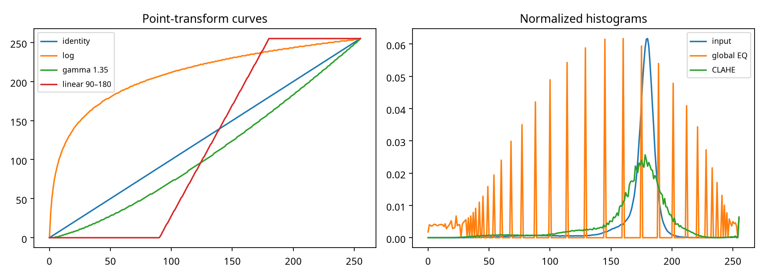
Figure 1. Point-transform curves and normalized input/output histograms for a representative DIBCO page.
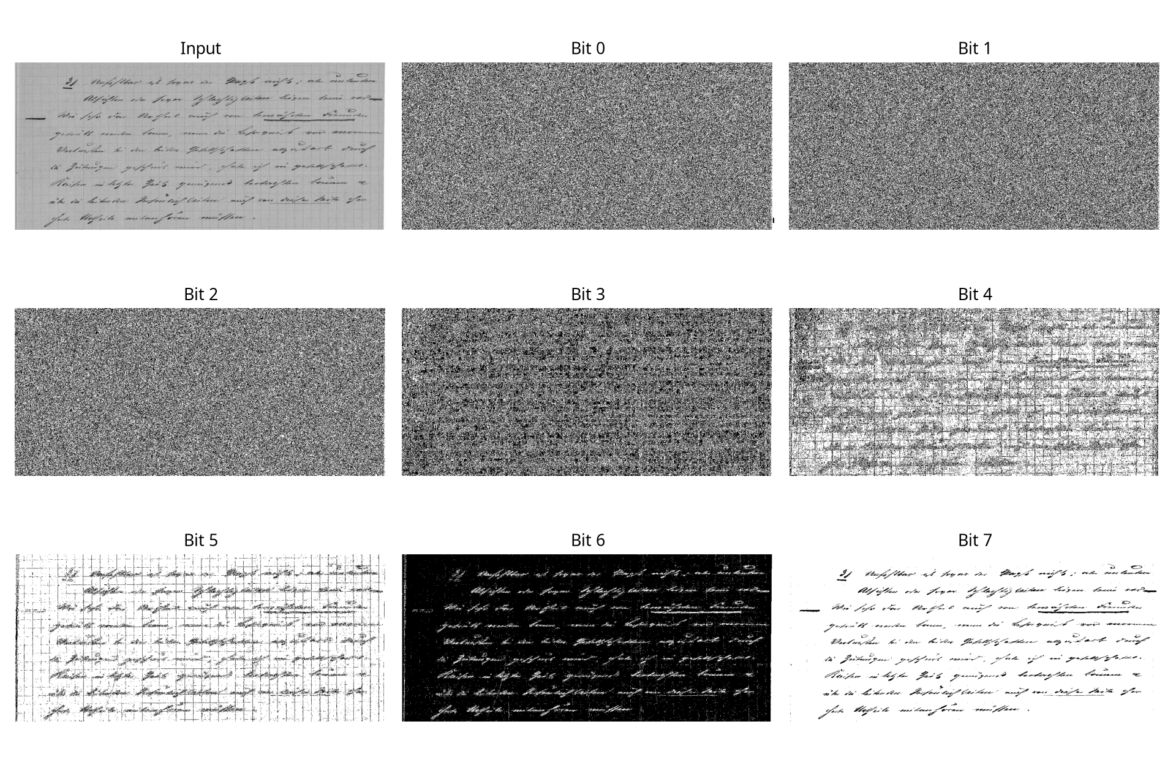
Figure 2. Bit-plane slicing. Higher planes generally carry broad text/background structure; lower planes show increasingly fine texture and noise. This is a visual diagnostic, not a pixel-accuracy score.
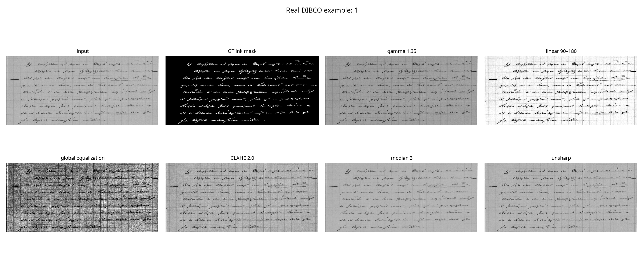
Figure 3. Representative real document outputs and ground-truth ink mask.
Decision: use a mild, data-calibrated transform rather than unconditional global stretching. Store the transformed image in grayscale and generate the OCR binary image in a separate thresholding stage.

3. Task 2 — Histogram processing
Technique | Ink–paper gap | Global contrast (SD) | Paper-region SD
global equalize | 130.0 | 76.8 | 73.0
cdf match | 70.9 | 23.0 | 16.0
clahe 2 8x8 | 117.0 | 41.3 | 31.8
clahe high 10 8x8 | 125.8 | 61.1 | 55.4

Global equalization produced a large overall standard deviation, but also raised the blank-paper standard deviation substantially. This is the expected risk on a page where most pixels are paper: the mapping is dominated by the paper histogram, and small background variations can become visible. CLAHE with clip limit 2.0 and an 8 × 8 tile grid increased text/paper separation while keeping the paper-region variation below the high-clip setting. Raising the clip limit to 10.0 increased both the mean gap and background variation, so it is not the safe default for a grainy phone image.
The CDF match uses the first benchmark page as a fixed reference mapping because a separate clean reference page was not supplied. It is a specification-style CDF-to-CDF implementation, not evidence that this reference is clean. For a production scanner, use a verified clean reference or prefer local CLAHE with restrained clipping. A global CDF cannot remove a spatially varying shadow because it applies the same mapping at every location; local tiles can adapt to local illumination, at the cost of possible tile boundaries.
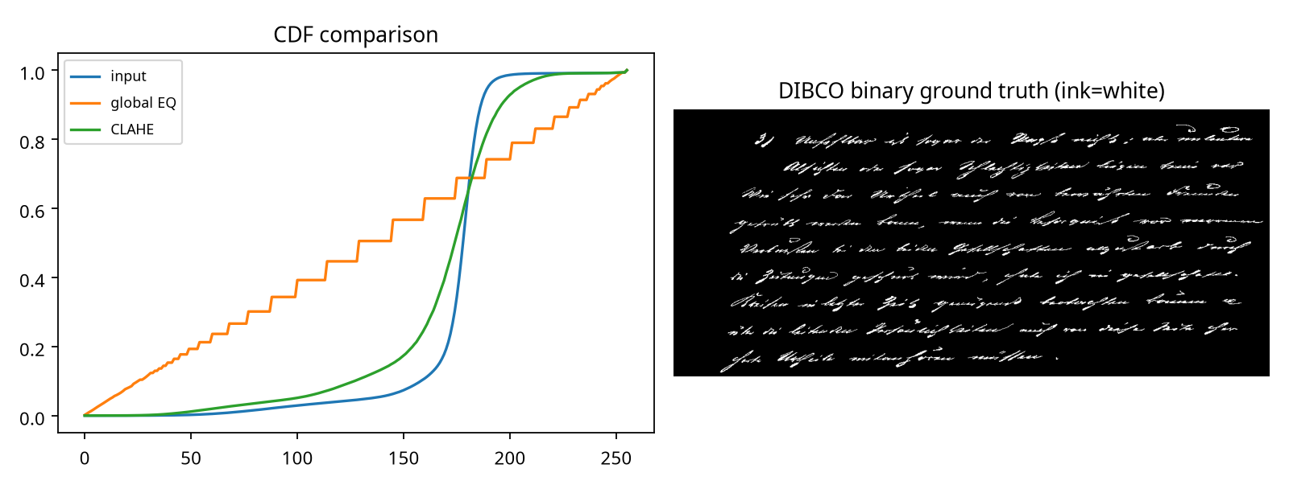
Figure 4. Cumulative-distribution comparison and paired binarization ground truth.

4. Task 3 — Smoothing filters
Filter | Dice after Otsu | Variance of Laplacian | Paper-region SD
box 3 | 0.582 | 170.1 | 19.4
gaussian 3 | 0.626 | 262.8 | 19.3
median 3 | 0.646 | 667.7 | 19.0
box 5 | 0.477 | 38.8 | 19.0
gaussian 5 | 0.570 | 99.5 | 19.0
median 5 | 0.461 | 211.2 | 17.9
box 7 | 0.415 | 16.2 | 18.1
gaussian 7 | 0.512 | 33.5 | 18.6
median 7 | 0.345 | 81.7 | 16.6

The 3 × 3 median filter achieved the best average Dice after the same Otsu thresholding step among the tested denoisers. The 3 × 3 Gaussian result was close. Increasing the kernel to 7 × 7 reduced Dice and Laplacian variance, consistent with blurred or broken thin strokes. A median filter is a practical choice for isolated salt-and-pepper dust; Gaussian smoothing is preferable for mild Gaussian grain when preserving continuous stroke edges is the priority. The present benchmark does not include paired clean grayscale targets or controlled injected noise, so PSNR and SSIM are not reported.
A 7 × 7 box filter is too wide relative to the assignment’s 2–4-pixel strokes. It suppresses both small specks and punctuation. Skipping smoothing before edge detection allows grain to trigger short edges and false point responses. Use the smallest kernel that addresses the observed noise, and do not smooth indiscriminately before the final binary-mask evaluation.
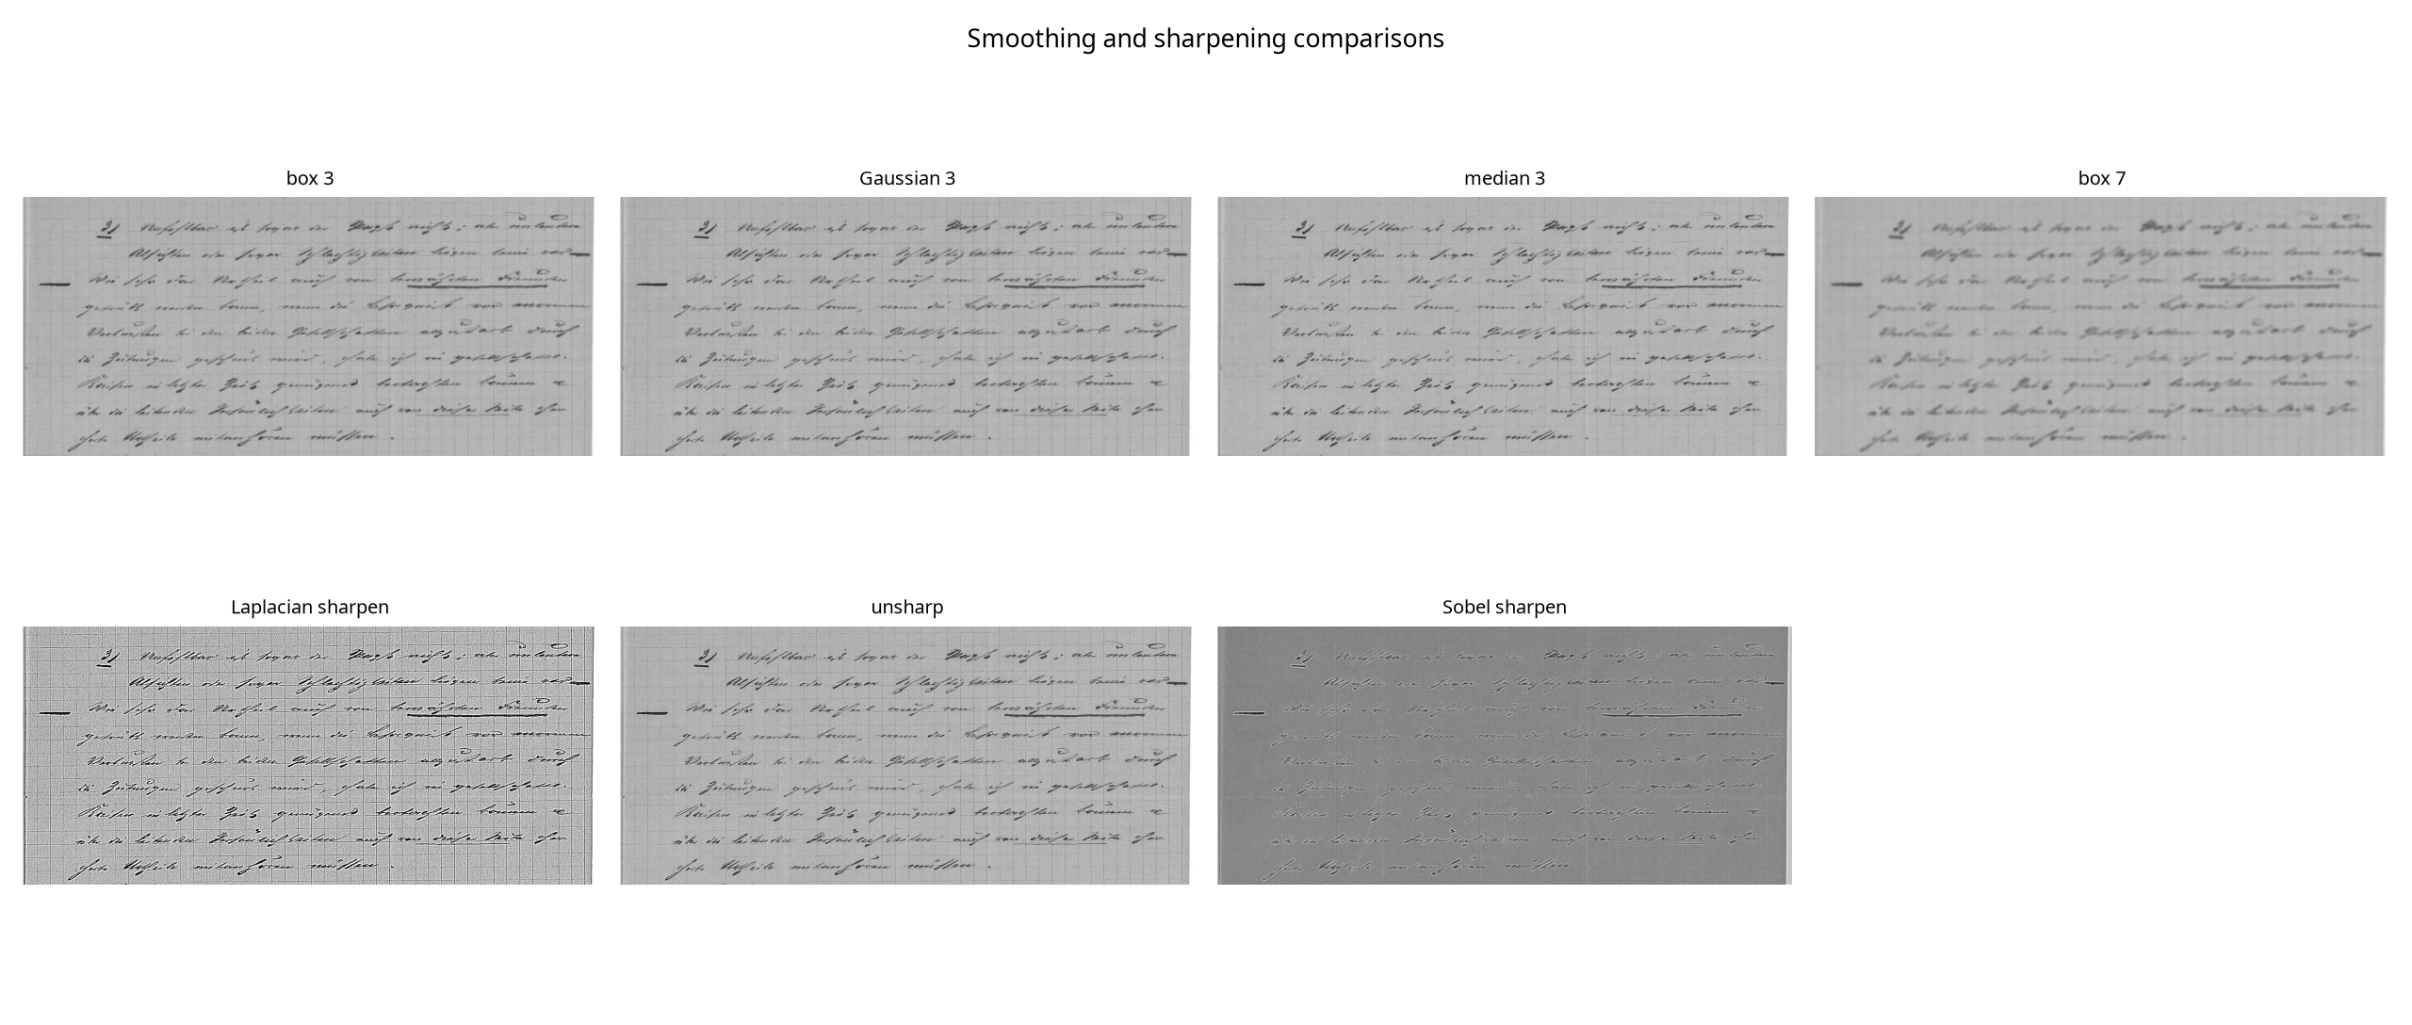
Figure 5. Example smoothing and sharpening outputs.
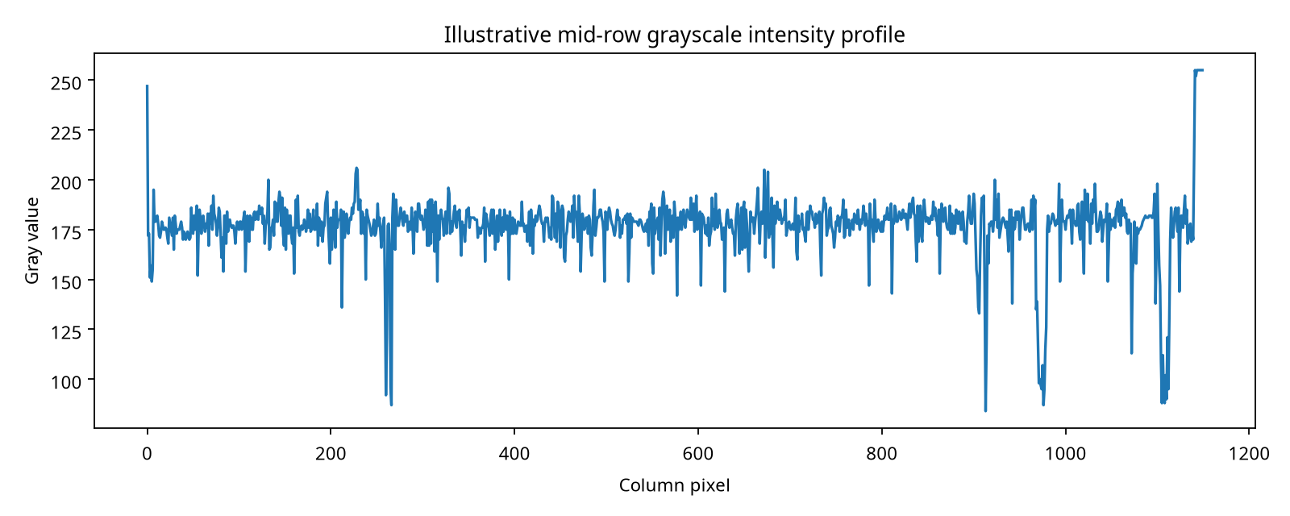
Figure 6. Grayscale intensity profile across a representative image row; abrupt troughs correspond to dark strokes, with background variation between them.
5. Task 4 — Sharpening filters
Technique | Dice after Otsu | Variance of Laplacian | Paper-region SD
laplacian smooth | 0.622 | 15162.3 | 42.1
unsharp k0.5 | 0.732 | 3942.1 | 22.1
sobel added | 0.396 | 2383.3 | 17.2

Mild unsharp masking (k = 0.5 in the implemented weighted blend) gave the strongest threshold Dice of the tested sharpening variants. The Laplacian sharpened image had the largest sharpness proxy but also a much higher paper-region standard deviation, indicating that fine background changes were amplified. The Sobel-added variant had a lower Dice score. A second derivative responds strongly to rapid changes on both sides of a stroke and can create halos; a first derivative emphasizes edge magnitude but may thicken the apparent edge when simply added back. The selected sequence is light smoothing followed by low-gain unsharp masking, then thresholding.
A large high-boost factor on a noisy, unsmoothed phone photo increases noise and halo risk. A signed Laplacian must be combined with the original image using an explicit scale and range. Displaying the raw signed response as unsigned gray clips negative values and is not a valid sharpening result. No OCR transcript was supplied, so character/word error rates and a pretrained deblurring comparison were not measured.
6. Task 5 — Frequency-domain low-pass filters
Low-pass filter | Mean Dice after Otsu | Runtime (ms/page) | Variance of Laplacian
ideal lp | 0.301 | 37.6 | 3.9
butterworth lp | 0.325 | 48.3 | 3.6
gaussian lp | 0.351 | 48.7 | 5.4

D₀ / short-side | Ideal Dice | Butterworth Dice | Gaussian Dice
0.03 | 0.209 | 0.226 | 0.252
0.06 | 0.312 | 0.338 | 0.364
0.1 | 0.383 | 0.412 | 0.437

At the tested cutoff fractions, low-pass filtering reduced edge sharpness and generally did not improve binarization Dice on this benchmark. The Gaussian response avoids the abrupt frequency cut-off of an Ideal filter, so ringing is expected to be less severe, but it still removes useful text-edge frequencies. The measured benchmark images do not establish the presence of the assignment’s periodic six-row scanner stripes. A targeted notch filter at observed stripe frequencies would be more defensible than broad low-pass filtering. The spectral image is included as an observation aid; no OCR CER/WER was measured because reference text was absent.
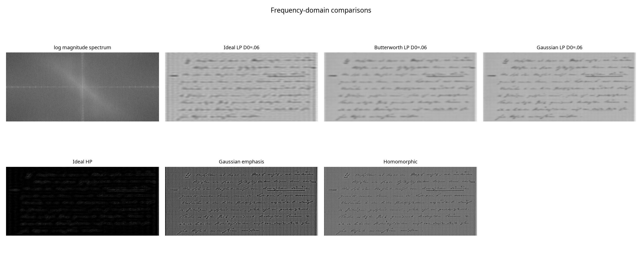
Figure 7. Log-magnitude spectrum and representative frequency-domain outputs.
7. Task 6 — Frequency-domain high-pass filters
Approach | Mean brightness | Standard deviation | Dice after Otsu
ideal hp | 7.3 | 11.1 | 0.124
butterworth hp | 6.7 | 10.0 | 0.127
gaussian emphasis | 98.9 | 34.6 | 0.587
homomorphic | 131.2 | 25.3 | 0.719

The unmodified Ideal and Butterworth high-pass outputs had a mean brightness near zero because they discard the DC component. They are edge-response images, not acceptable digitization images by themselves. Gaussian high-frequency emphasis retains a low-frequency baseline and increases edge content. Homomorphic filtering produced the best measured binarization Dice of these frequency approaches on the benchmark. It remains a classical candidate for uneven illumination, not a substitute for evidence from shadow-labeled phone photos. In homomorphic filtering, γL controls low-frequency illumination and γH controls high-frequency reflectance; swapping them would brighten/attenuate the wrong components and undermine the intended correction.
8. Task 7 — Point, line and edge detection
The executed examples include a Laplacian point-response map, a horizontal morphological line response and a Canny edge map. The point threshold was fixed at 35 gray levels on the smoothed Laplacian magnitude, and Canny used 50/150. They are visual starting values only: the DIBCO ground truth labels ink, not dust specks, ruled lines or page borders, so point/line/border precision and recall cannot be calculated from these files.
An isolated point mask can respond to punctuation and tiny character fragments as well as dust. Four directional 3 × 3 masks can miss a slightly tilted line because their orientation bins are coarse; rotate the image or use a Hough transform with an angle tolerance. Canny is more suitable for a continuous page edge after denoising, but letters and shadows create competing edges. A learned HED detector was not evaluated because no checkpoint and feature annotations were provided.
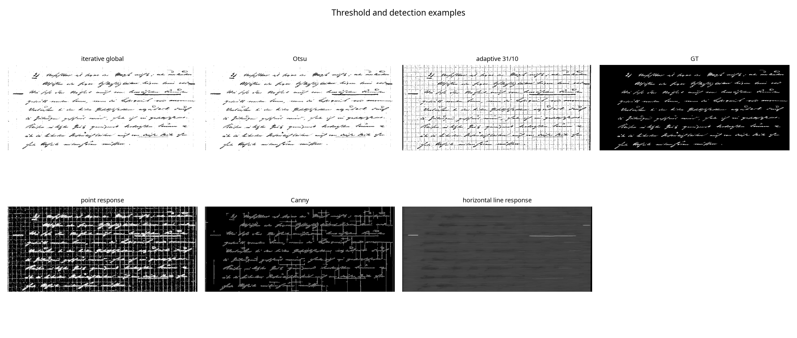
Figure 8. Point, line, edge and threshold examples; annotation-dependent precision and recall are unavailable.
9. Task 8 — Thresholding and binarization
Method | Mean Dice | Mean foreground fraction
iterative global | 0.720 | 10.1%
otsu | 0.723 | 10.0%
adaptive gaussian 31 C10 | 0.519 | 14.8%

Otsu gave the highest mean Dice on the ten DIBCO pages under the fixed evaluation setup. The adaptive Gaussian method used a 31-pixel window and C = 10. It is better motivated for spatially varying shadows, but its result on this specific cohort was less accurate on average. A local window smaller than the character dimensions can fragment strokes; a large window can merge nearby text and stains. The iterative global baseline was implemented as repeated two-class mean updates and evaluated with the same ink polarity.
When illumination changes across the page, the observed image can be treated as f(x,y) = i(x,y)r(x,y), where i is illumination and r is reflectance. A single global threshold on f may classify the shadowed paper as foreground. Smoothing can stabilize Otsu only if its benefit is confirmed with a matched clean target; here the filter/threshold comparisons use the same DIBCO masks and show that excessive smoothing lowers Dice. Otsu is the selected default for well-lit pages; adaptive thresholding is a conditional path for measured shadowed pages.
10. Task 9 — Region segmentation and integrated pipeline
No stain-region, punch-hole or page-border annotations are present in the selected public sample, so region-growing IoU and page-corner error cannot be measured. The qualitative design choice is to reserve seed-based region growing for a staff-selected stain area, where the seed is verified to lie inside a stain. An automatic seed on a text character can cause leakage into similar dark strokes. For cropping, smooth first, detect candidate page edges, link them with Hough/contour processing, and reject quadrilaterals whose geometry is implausible. A shadow break in a page boundary can be bridged using line fitting and corner constraints before perspective correction.
A quadtree can separate large illumination regions but risks splitting text into many small regions and needs a merge rule. For a simple CPU pipeline, OpenCV contours plus Hough line hypotheses are a reasonable low-cost page-border baseline. Watershed requires markers; SAM 2 requires prompts and substantial model resources. These alternatives were not benchmarked on identical stain/boundary labels, so the selection remains provisional.
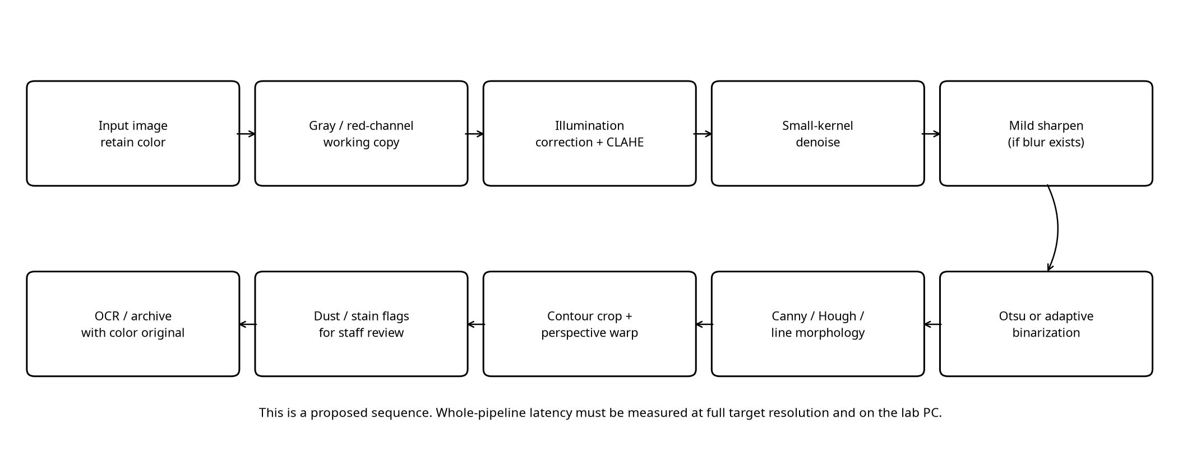
Figure 9. Recommended classical scanner pipeline. Stage timing must be re-measured at the target A4 resolution and on the target lab PC.
Decision | Evidence in this run | If not selected
CLAHE, clip 2.0 | Higher text/paper gap than CDF matching with less paper variation than clip 10 | Global shadow remains; excessive clipping increases noise
Median 3 × 3 for impulse specks | Best mean Dice among tested smoothing filters | Larger kernels blur small text and punctuation
Unsharp mask, low gain | Best Dice among tested sharpeners | Laplacian/noise halos can alter weak marks
Otsu for ordinary pages | Highest DIBCO mean Dice | May fail under strong local shadow
Hough + contours for crop; optional grow for stains | Practical classical design; no relevant GT available | Corner/stain accuracy is unverified

11. Task 10 — Adaptation to phone photographs
Strategy | Mean runtime (ms/page) | Working scale | What it tests
RETAIN gray full CLAHE adaptive | 224.4 | native | Pixel accuracy unavailable
MODIFY resize1200 red CLAHE adaptive | 85.4 | max side 1,200 | Pixel accuracy unavailable
REDESIGN resize1200 homomorphic adaptive | 224.5 | max side 1,200 | Pixel accuracy unavailable

The public DocUNet photos show why the old assumptions cannot be retained unchanged: images are color camera photos, can be perspective-distorted and have different resolutions. The RETAIN path processes full-resolution grayscale with CLAHE and adaptive thresholding. MODIFY reduces the image to a 1,200-pixel long side and uses the red channel as a candidate for making blue ink darker before CLAHE and local thresholding. REDESIGN adds homomorphic correction at the reduced resolution. The measured time table includes the listed preprocessing and thresholding stages; it does not include page-boundary localization or perspective warp.
No blue-pen labels or ground-truth page corners accompany the selected DocUNet originals. Therefore the channel choice, note preservation, Dice, corner error and exact compliance with the one-second service target are not proven by accuracy evidence. The suitable conclusion is MODIFY as the next testable design, not an evidence-complete final approval. Keep the original color image and retain a separate color layer for margin notes; do not discard color until note preservation is checked. Frequency filtering for JPEG 8 × 8 artifacts and perspective correction should be added only after measured benefit, as broad frequency smoothing can erase strokes.
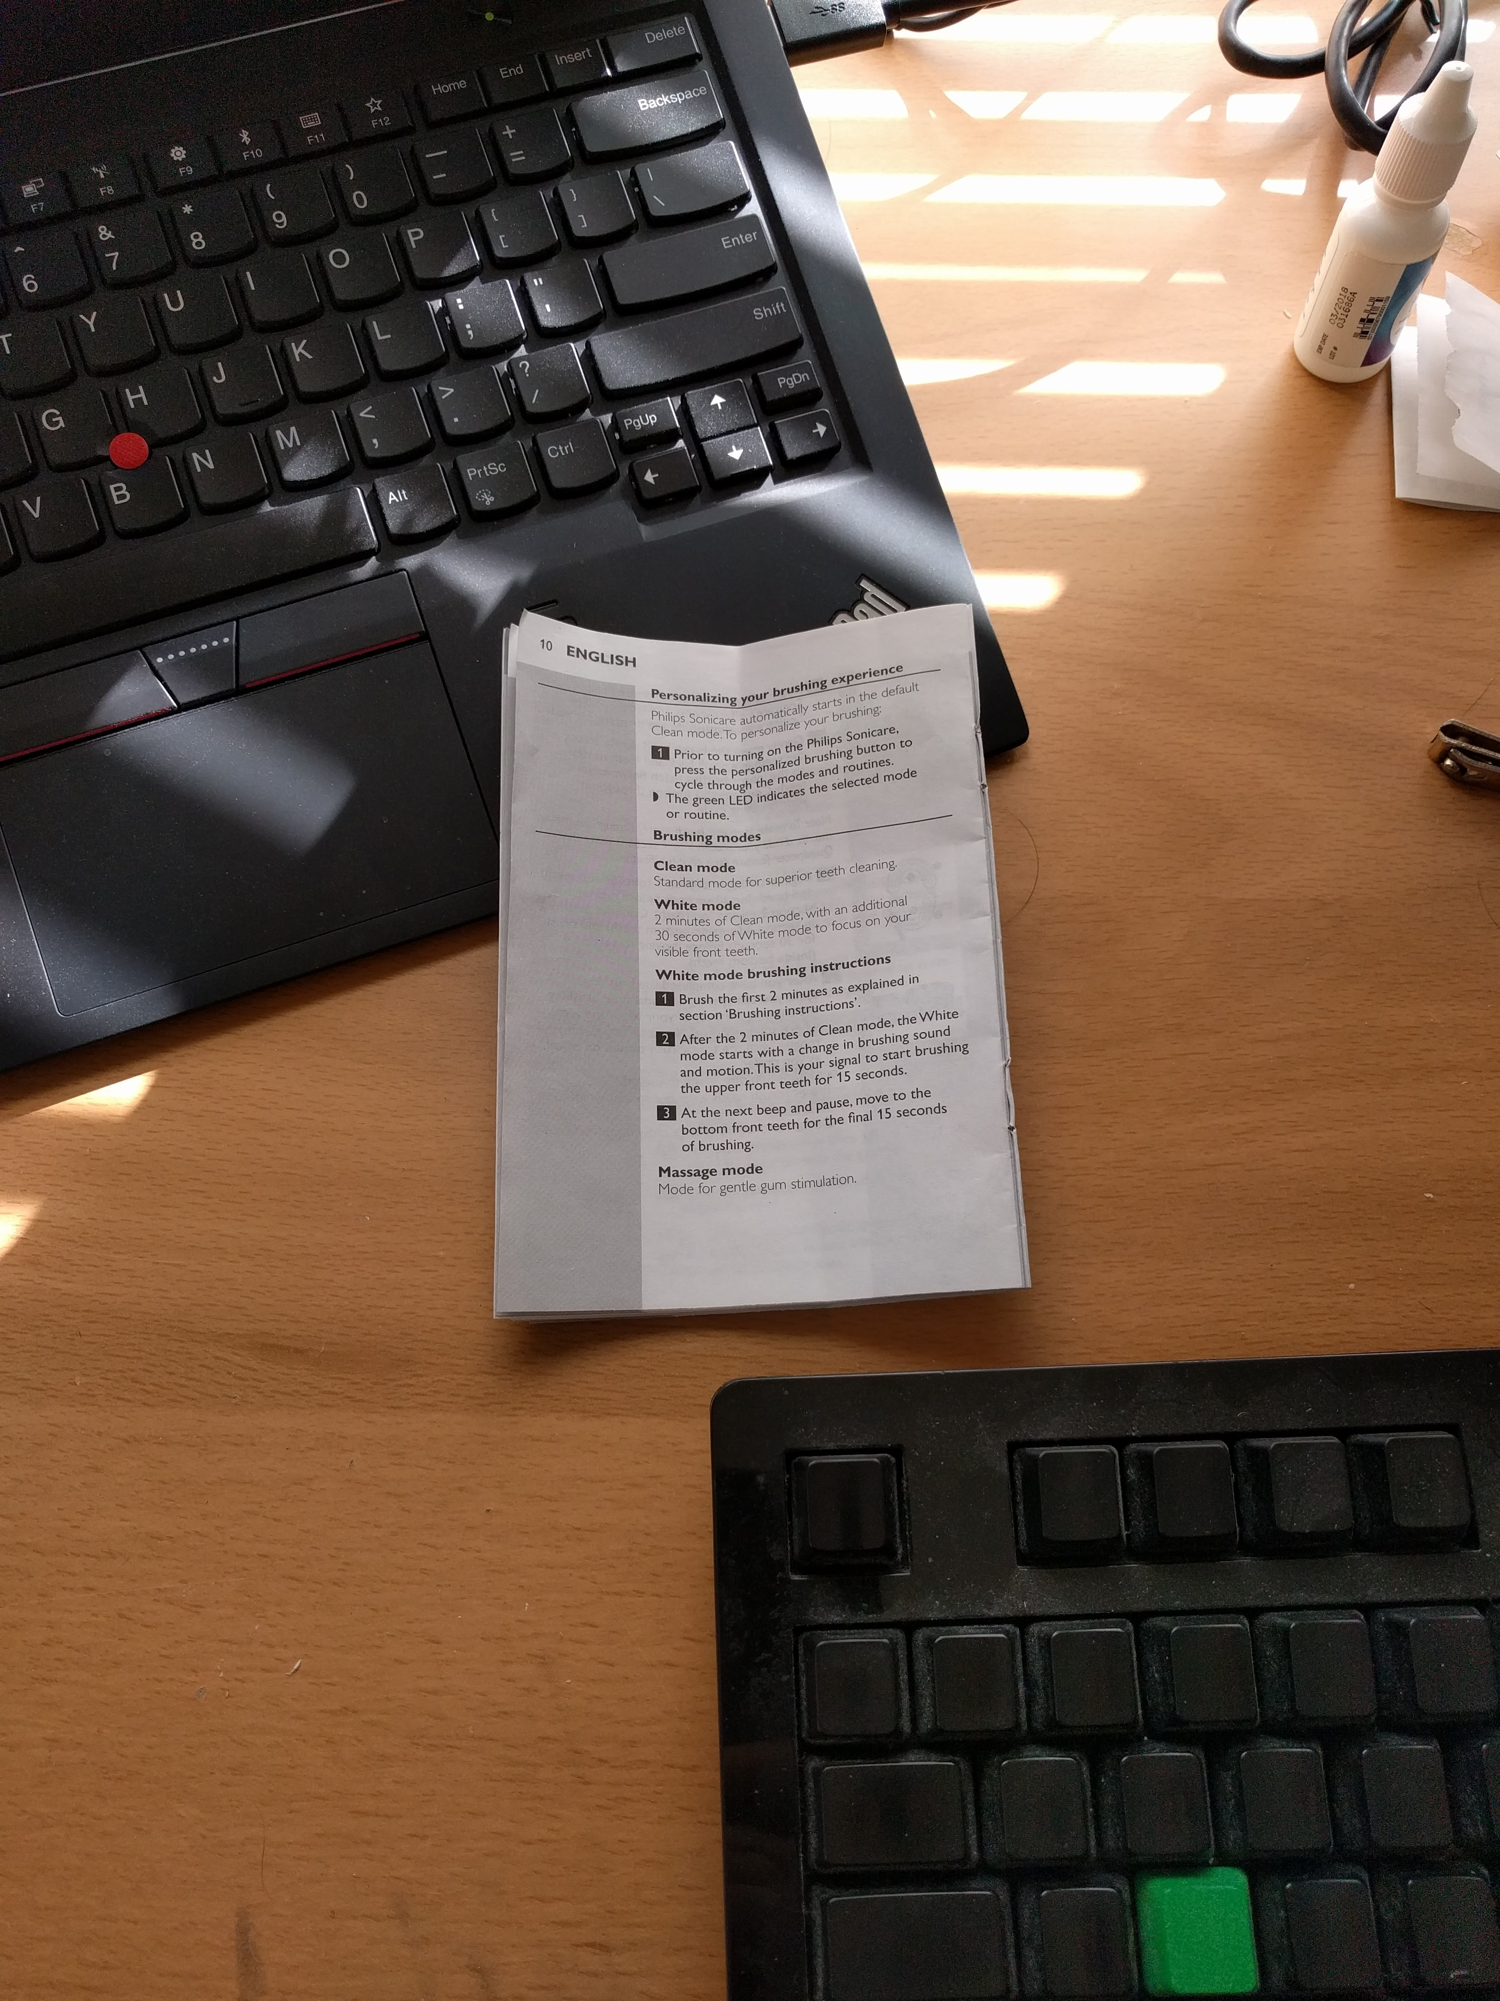
Figure 10. Representative original DocUNet phone photograph used in the adaptation check.
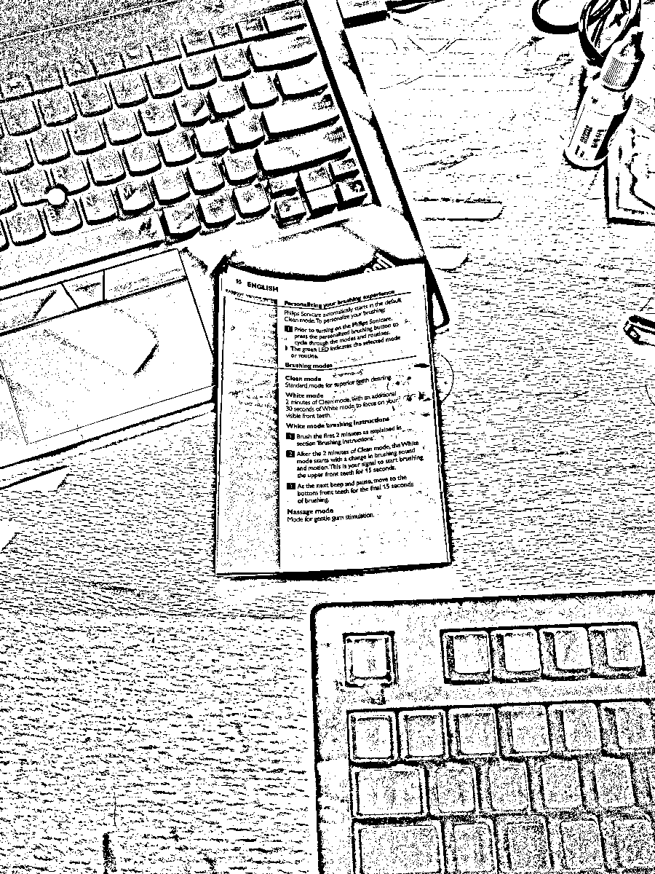
Figure 11. Reduced-scale red-channel, CLAHE and adaptive-threshold output. Not a validated blue-pen preservation score.
Document-AI models such as LayoutLMv3 or Donut can assist with recognition and layout interpretation, but they do not replace geometric page detection, color retention, or a verified binary mask when those are explicit output requirements. This model comparison was not executed here.

12. Final design decisions
For ordinary scanned pages, the evidence supports a conservative classical pipeline: grayscale conversion with retained color source; CLAHE at clip limit 2.0 on an 8 × 8 tile grid when local contrast needs help; a 3 × 3 median filter for visible impulse specks; optional low-gain unsharp masking after smoothing; Otsu thresholding for normally illuminated pages; adaptive thresholding only when local shadow is present; then separate detection stages for lines, page edges and staff-review annotations. Use perspective correction only after stable page corners are found.
The real DIBCO measurements support several classical choices, especially small-kernel smoothing, modest unsharp masking and Otsu on this benchmark. They do not validate the full scanner against the assignment’s custom targets. In particular, the 0.90 Dice target, three-second A4 runtime, OCR quality, stain completeness, page-corner accuracy and one-second 12-megapixel adaptation target remain unverified. The next valid step is to collect the specified student pages and phone photos and annotate text, stains, lines and corners, then rerun the supplied code and add the required learned-model comparison.
Appendix A — Reproduction and measured limitations
The companion Python source file is run_assignment2.py. It downloads no data by itself. The benchmark files used here were obtained from the official DIBCO 2019 Track A listing, and the selected DocUNet original-photo files were read from the official ZIP archive using range requests. Python requirements are OpenCV, NumPy, Matplotlib, scikit-image and pandas. The script writes CSV measurements, JSON summaries, example images and plots under the out/ directory.
The 3 × 3 filter verification used the sample patch [[10,20,30],[40,50,60],[70,80,90]] and the asymmetric mask [[1,2,0],[0,−1,−2],[2,1,1]]. The manual correlation is 190 and matches cv2.filter2D at the center pixel. Flipping the mask before cv2.filter2D gives the convolution value 210. This verifies that OpenCV’s filter2D operation uses correlation and that mathematical convolution requires a 180-degree kernel flip. BORDER_REFLECT is recommended for page filtering because it avoids an artificial zero-valued dark border; compare against zero padding when the page edge itself is the feature of interest.
Executed check: manual correlation = 190; filter2D correlation = 190; manual convolution = 210; filter2D with flipped kernel = 210.
Important unavailable evaluations: PSNR/SSIM needs paired clean grayscale targets or a known corruption process; CER/WER needs verified transcription; dust/line/page-border precision and recall, stain IoU and corner error need matching annotations. A pretrained-model comparison additionally needs a specified accessible checkpoint and consistent inference setup. None of these values has been inferred from visual inspection.
Reproduction commands and files
Install the dependencies with: python3 -m pip install opencv-python-headless numpy matplotlib scikit-image pandas. Place the ten DIBCO Track A images below data/dibco/images and masks below data/dibco/gt, preserving matching filenames. Place the selected DocUNet original photos below data/docunet/original. Then run: python3 run_assignment2.py. The script writes enhancement_metrics.csv, task_metrics.csv, parameter_sensitivity.csv, task10_strategy_metrics.csv, summary.json, figures and examples under out/.
The companion evidence archive contains the Word report, source runner, raw CSV/JSON results, generated charts and representative output images. The public image archives themselves are not embedded; retrieve them from the URLs in the References section and observe their source terms.
References
[1] ICDAR 2019 Competition on Document Image Binarization, official benchmark listing and Track A files. https://vc.ee.duth.gr/dibco2019/benchmark/
[2] K. Ma et al., “DocUNet: Document Image Unwarping via a Stacked U-Net,” CVPR 2018. Official dataset page and original-photo archive. https://www3.cs.stonybrook.edu/~cvl/docunet.html
[3] Assignment 2 brief supplied with this report: operating assumptions, methods, targets and evidence requirements.

